ITA0510 COMPUTER VISION
LAB ACTIVITY:
6. Perform basic video processing operations on the captured video
AIM: Read captured video in python and display the video, in slow motion and in fast motion.
Algorithm
- Import the OpenCV library.
- Load the video using cv2.VideoCapture().
- Read the video frame by frame.
- Display each frame using cv2.imshow().
- Control the playback speed using cv2.waitKey().
- Press Q to stop the video.
- Release the video and close all windows.
CODE:
import cv2
cap = cv2.VideoCapture("sample_video.mp4")
while cap.isOpened():
ret, frame = cap.read()
if not ret:
break
frame = cv2.resize(frame, (640, 480))
cv2.imshow("Video", frame)
if cv2.waitKey(5) & 0xFF == ord('q'):
break

cap.release()
cv2.destroyAllWindows()

OUTPUT:
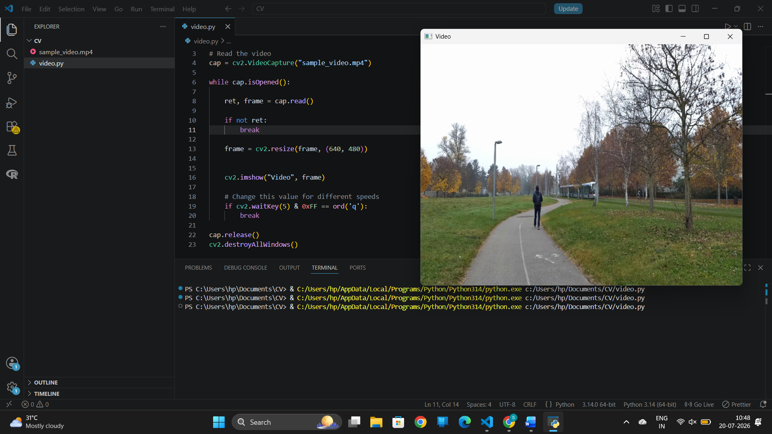
RESULT: Thus the program is executed successfully.

7)
AIM: Capture video from web Camera and Display the video, in slow motion and in fast motion. operations on the captured video
Algorithm
- Import the OpenCV library.
- Access the webcam using cv2.VideoCapture(0).
- Read video frames continuously from the webcam.
- Resize the frame if required.
- Display each frame using cv2.imshow().
- Change the value of cv2.waitKey() to display the video in normal, slow, or fast motion.
- Press Q to stop capturing the video.
- Release the webcam and close all OpenCV windows.
CODE:
import cv2
cap = cv2.VideoCapture(0)
while True:
ret, frame = cap.read()
if not ret:
break
frame = cv2.resize(frame, (640, 480))
cv2.imshow("Webcam Video", frame)
if cv2.waitKey(5) & 0xFF == ord('q'):
break
cap.release()
cv2.destroyAllWindows()
OUTPUT:
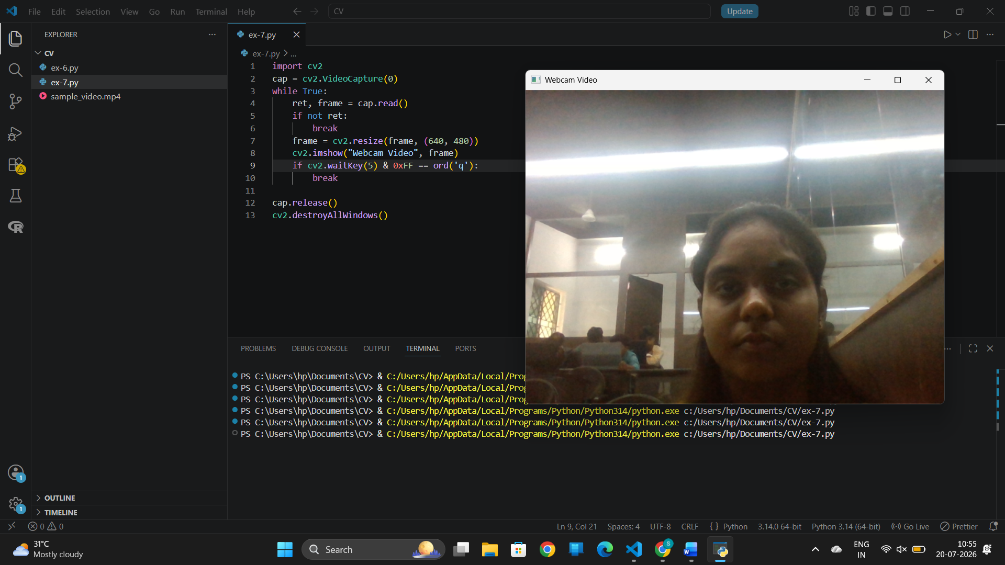
RESULT: Thus the program is executed successfully.
8. Scaling an image to its Bigger and Smaller sizes.
AIM: Converting an image to image to its Bigger and Smaller sizes.
Algorithm
- Import the required libraries (cv2 and cv2_imshow).
- Read the input image using cv2.imread().
- Scale the image to a larger size using cv2.resize().
- Scale the image to a smaller size using cv2.resize().
- Display the original, bigger, and smaller images.
- End the program.
CODE:
import cv2
from google.colab.patches import cv2_imshow
img = cv2.imread("/content/yu-chin-tsai-piTEABtlR1Q-unsplash.jpg")
bigger = cv2.resize(img, None, fx=2, fy=2)
smaller = cv2.resize(img, None, fx=0.5, fy=0.5)
print("Original Image")
cv2_imshow(img)
print("Original Size :", img.shape)
print("Bigger Image")
cv2_imshow(bigger)
print("Bigger Size :", bigger.shape)
print("Smaller Image")
cv2_imshow(smaller)
print("Smaller Size :", smaller.shape)
OUTPUT:
Original Image
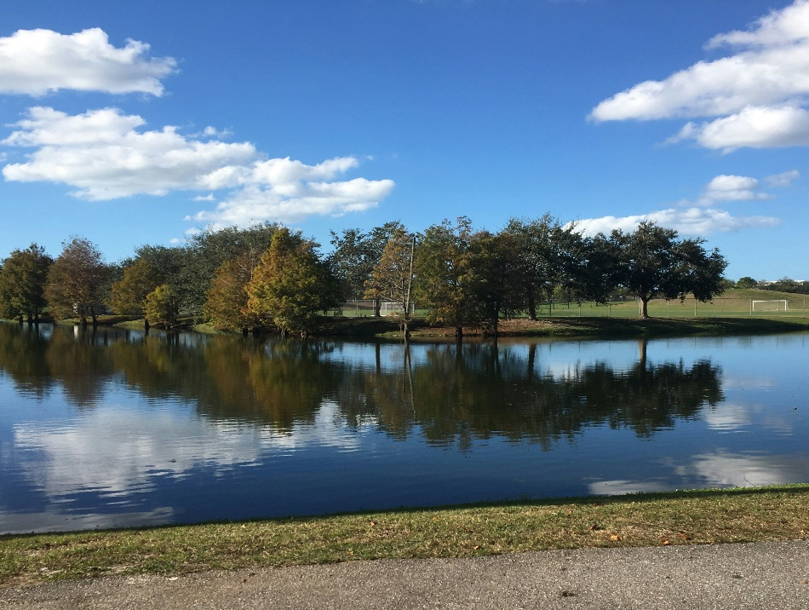
Original Size : (2618, 2618, 3)
Bigger Image
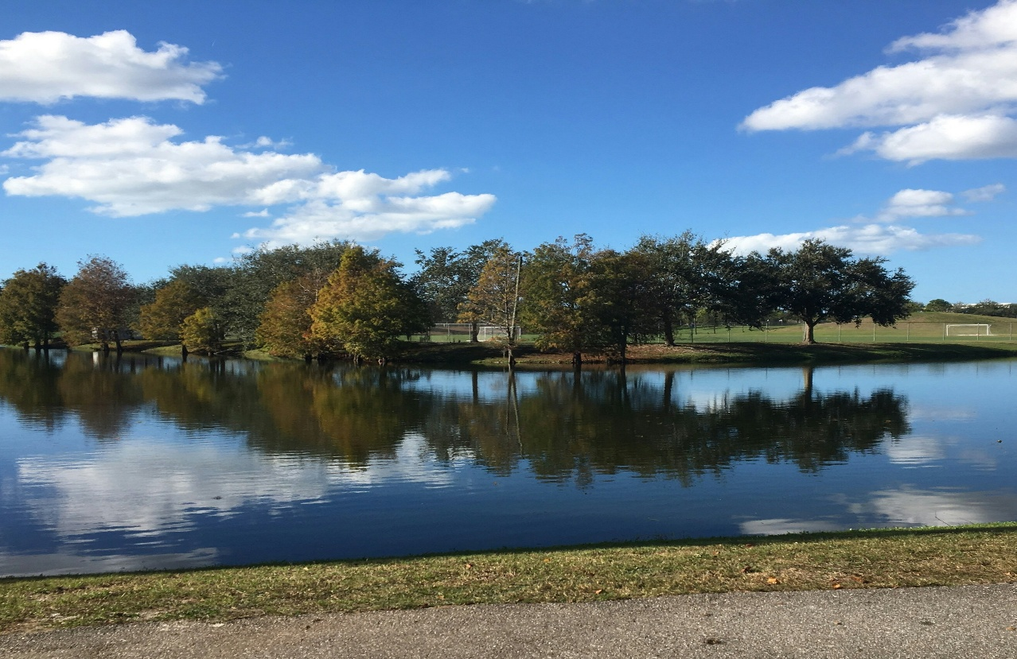
Bigger Size : (5236, 5236, 3)
Smaller Image
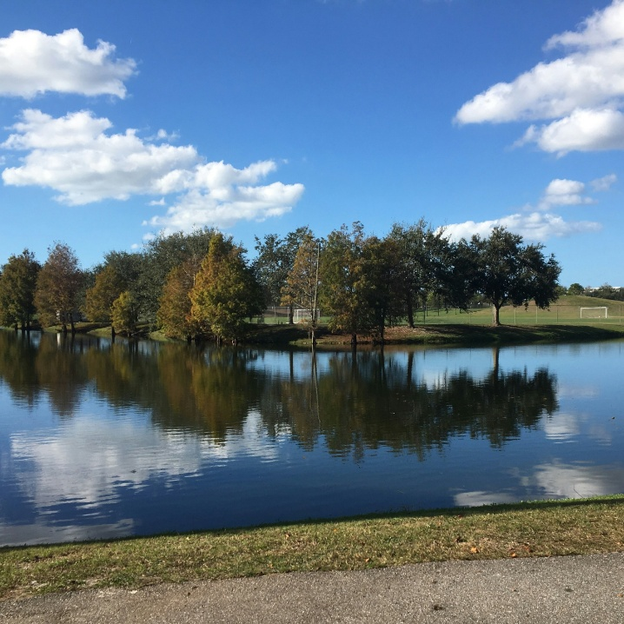
Smaller Size : (1309, 1309, 3)
RESULT: Thus the program is executed successfully.

9. Perform Rotation of an image to clockwise and counter clockwise direction.
AIM: Rotation of an image to clockwise and counter clockwise direction.
Algorithm
- Import the required libraries (cv2 and cv2_imshow).
- Read the input image using cv2.imread().
- Rotate the image 90° clockwise using cv2.rotate().
- Rotate the image 90° counter-clockwise using cv2.rotate().
- Display the original, clockwise, and counter-clockwise rotated images.
- End the program.
CODE:
import cv2
from google.colab.patches import cv2_imshow
img = cv2.imread("/content/yu-chin-tsai-piTEABtlR1Q-unsplash.jpg")
clockwise = cv2.rotate(img, cv2.ROTATE_90_CLOCKWISE)
counter_clockwise = cv2.rotate(img, cv2.ROTATE_90_COUNTERCLOCKWISE)
print("Original Image")
cv2_imshow(img)
print("Clockwise Rotated Image")
cv2_imshow(clockwise)
print("Counter Clockwise Rotated Image")
cv2_imshow(counter_clockwise)
OUTPUT:
Original Image
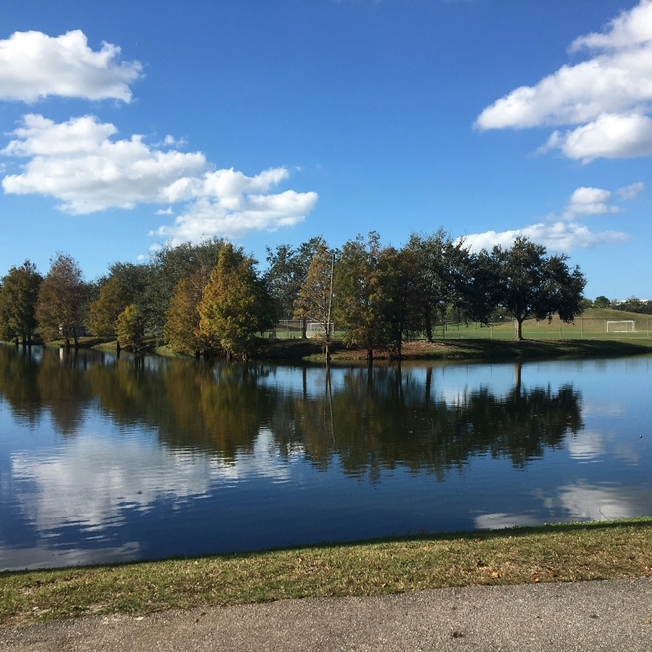
Clockwise Rotated Image
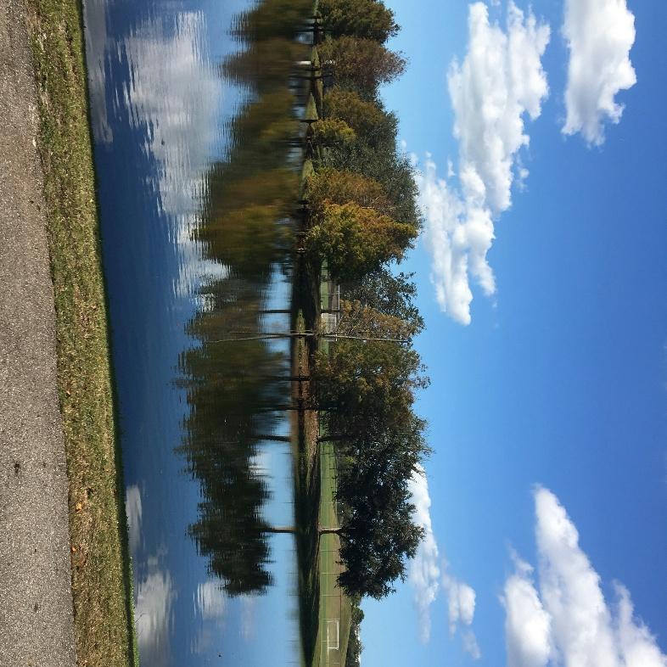
Counter Clockwise Rotated Image
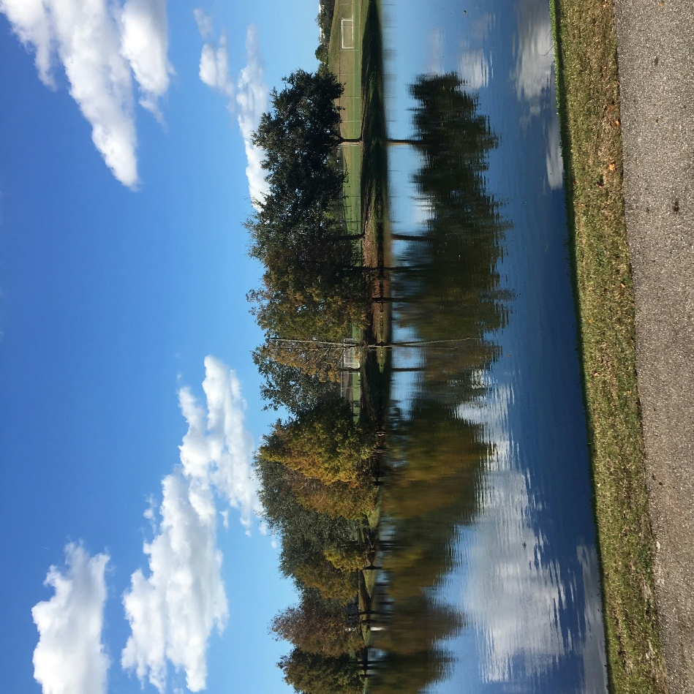
RESULT: Thus the program is executed successfully.

10. Perform moving of an image from one place to another.
AIM: Moving of an image from one place to another.
Algorithm
- Import the required libraries (cv2, numpy, and cv2_imshow).
- Read the input image using cv2.imread().
- Define the translation values along the x-axis and y-axis.
- Create a translation matrix.
- Apply the translation using cv2.warpAffine().
- Display the original and translated images.
- End the program.
CODE:
import cv2
import numpy as np
from google.colab.patches import cv2_imshow
img = cv2.imread("/content/yu-chin-tsai-piTEABtlR1Q-unsplash.jpg")
rows, cols = img.shape[:2]
M = np.float32([[1, 0, 100],
[0, 1, 50]])
translated = cv2.warpAffine(img, M, (cols, rows))
print("Original Image")
cv2_imshow(img)
print("Translated Image")
cv2_imshow(translated)
OUTPUT:
Original Image
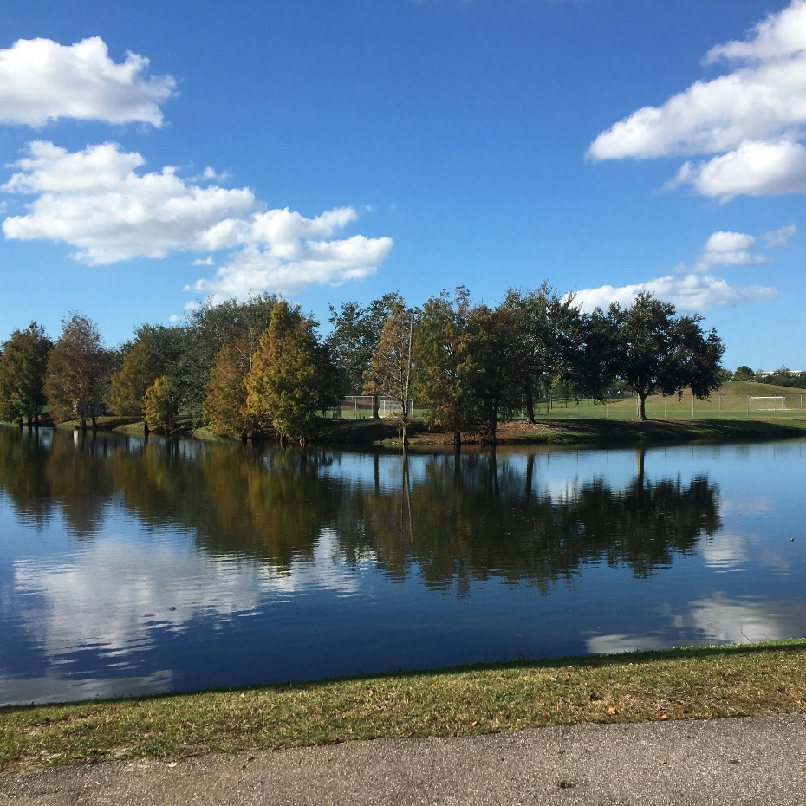
Translated Image
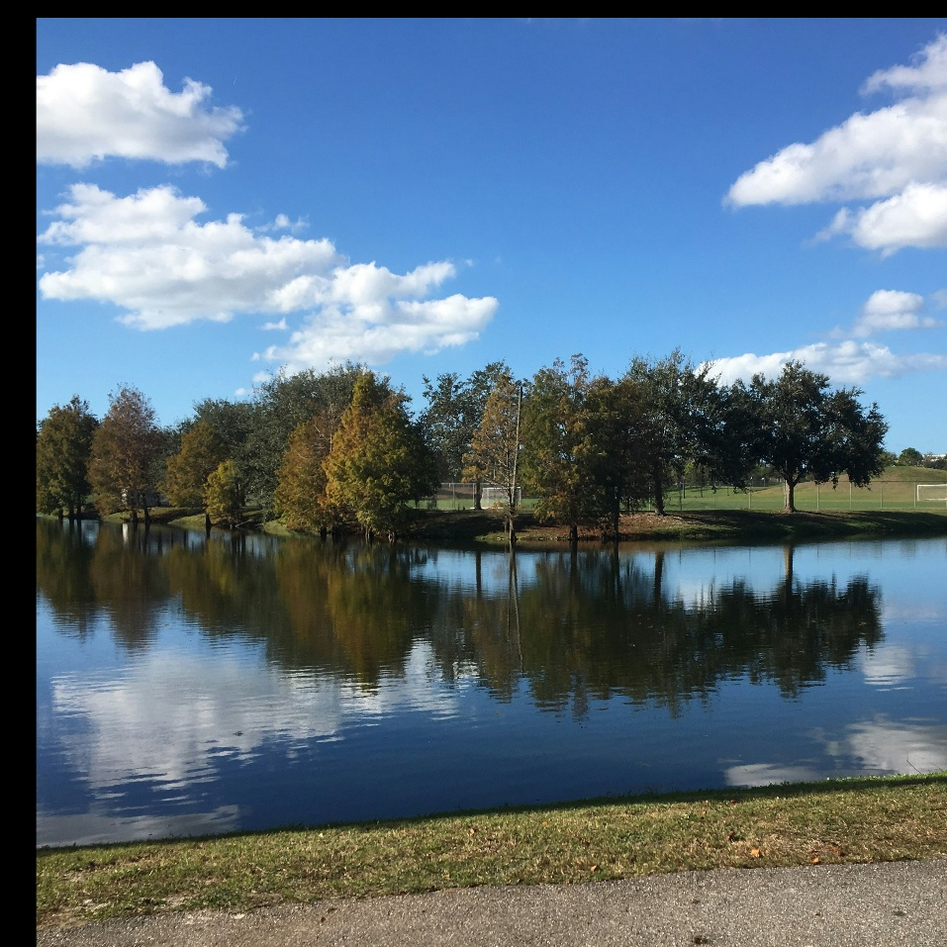
RESULT: Thus the program is executed successfully.

